Day 1

React JS Training

7/3/2023

<https://www.google.com> URL : Uniform Resource Locator

req(http/https)----------------🡪

Client Server

🡨-------res(http/https) HTML/HTML5

HTML : Hyper text markup language : which help to create web page.

CSS : Cascading Style sheet :CSS provided lot of property and value which help to apply formatting style for web page.

JavaScript :JavaScript was object based interpreter scripting language. JavaScript mainly use to do validation on client side till ES5 JS.

ES : ECMA . ECMA is a concept and JavaScript is one of the implementation of ES.

But from ES6 onwards JavaScript also known as Object oriented interpreter scripting language.

VSCode :

DOM : document object model

When we run html page web on browser internally browser create DOM hierarchy

Html

Head body

Title h1

Meta div

Script

Style

DOM API (Document Object Model Application programming interface).

Lot of programming language provided function or method or classes which help to read, write and update html content (DOM)dynamically. Like Java, asp.net, python, JavaScript.

document.getElementById()

document.getElementsByName()

document.getElementsByClassName()

document.getElementsByTagName()

jQuery : jQuery is a third party javascript library which provide lot of pre defined function which help to read, write and update dom dynamically.

Angular

React JS

Angular is a framework and react js a library

Framework contains lot of modules or classes which internally connected to each other to perform a specific task. 70 to 80% task taken care by framework. Framework is not a final product. It is a template or protocol. If we develop any application with help of framework by default we follow standard. Because framework provided implementation of design pattern.

Limitation of framework.

Framework are heavy weighted.

React JS is an open source third party library provided by Facebook. Library always light weighted.

React JS with Flux or Redux we can make standard.

Before React and Angular we were creating multi page application.

Index.html welcome.html

Link

Button

Submit button

JavaScript code.

SPA (Single Page Application).

In Single Page Application rather than loading whole page or DOM we can load only part of web page.

React and Angular provided the features of SPA application.

Before SPA we are creating lot of web page independently and those web pages we are combining with help of frameset tags.

Header.html

Footer.html

Nav.html

Content.html

index.html it contains own dom.

with help of frameset tags we can combine these all html pages.

DOM.

Single page application

Index.html

Component Component is use to control the view or part of view on web page.

In React JS We can create component using function style (ES5) or Arrow style (ES6) or class style (ES6).

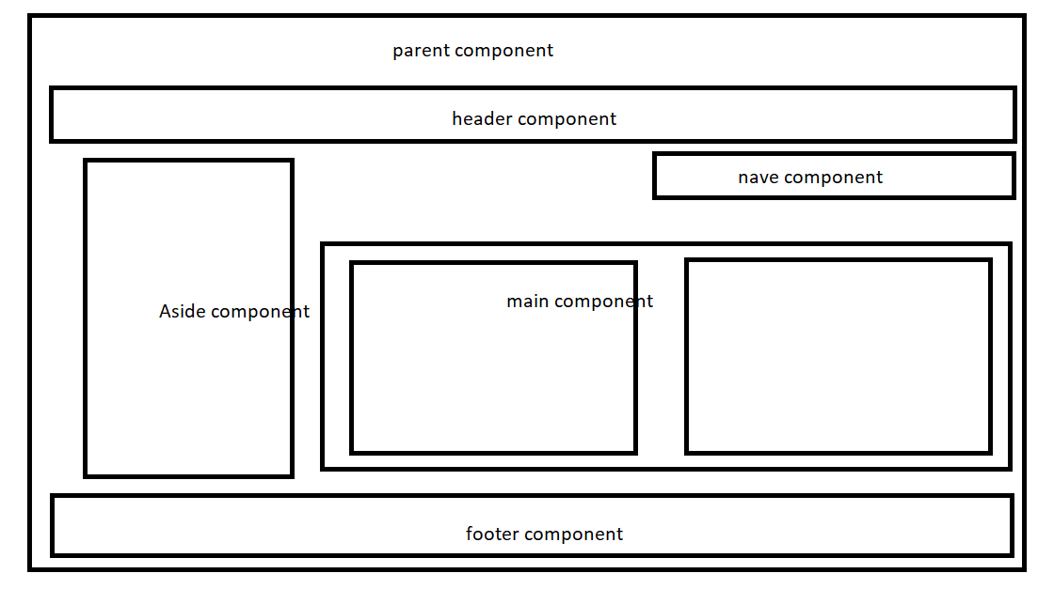

Function in JS

1. Normal function
2. Arrow function

Function style object creation

Class style object creation

object : object is any real world entity.

Property or state have

Person

Behaviour do/does

Bank

Customer

Car

Account

To implement this object in JavaScript

1. Literal style object creation ES5
2. Function style object creation ES5
3. Class style object creation ES6

ES6 can support constructor concept with class keyword.

1. Constructor is a type special function which help to create the object.
2. While writing the constructor in JavaScript we need to use constructor keyword in JavaScript for that function.
3. Normal function we need to call explicitly using object but constructor get called automatically when we create the object.

Node JS : Node JS is a run time environment for JavaScript library or framework.

Before Node JS JavaScript was known as Client side scripting language which run on browser.

But after node js JavaScript is known as Client side as well as Server side scripting language.

Means with help of node js we can do file handling, we can create serve side programming, we can connect database, we can do security related programs.

Like now a days server side technology like Java (Spring boot or spring framework), asp.net, php, python and node js.

Node js provided npm (node package manager) which help to install third party module which help to create angular or react js project.

npm install modulename -g

React JS help us to create user defined tags with help of component ie function style.

<p>Welcome</p>

<p>Welcome</p>

<h1>Welcome again</h1>

<h7>Welcome again and again</h7>

<h8>Welcome again and again</h8>

In React JS with help of component we are creating user defined tags.

JavaScript library and framework.